

**Our Aspirations**

Teaching and learning of P.E. throughout the school is planned and carried out through our curriculum values:

Aspiration Self-Belief Perseverance Independence Respect Enjoyment

The aims of P.E. in our school are:

* to provide a high-quality PE curriculum that will inspire in pupils a love and commitment to a variety of different sports and physical activity.
* to promote long term, healthy lifestyles - giving children a positive start in laying the foundations for active lives.
* to promote healthy competition and fair play within sport, giving students the opportunity to attend events with children from other schools.

**What does the National Curriculum say about P.E?**

Following the aims of the National Curriculum, at St Bernadette’s we will ensure:

* that children have the opportunity to excel in a broad range of physical activities
* children are physically active for sustained periods of time
* children engage in competitive sports and activities
* children lead healthy, active lives

At **Key Stage One**, we will teach children to:

* master basic movements including running, jumping, throwing and catching, as well as developing balance, agility and coordination, and begin to apply these in a range of activities
* participate in team games, developing simple tactics for attacking and defending
* perform dances using simple movement patterns

At **Key Stage Two**, we will teach children to:

* use running, jumping, throwing and catching in isolation and in combination
* play competitive games, modified where appropriate [for example, badminton, basketball, cricket, football, hockey, netball, rounders and tennis], and apply basic principles suitable for attacking and defending
* develop flexibility, strength, technique, control and balance [for example, through athletics and gymnastics]
* perform dances using a range of movement patterns
* take part in outdoor and adventurous activity challenges both individually and within a team
* compare their performances with previous ones and demonstrate improvement to achieve their personal best.

**What about EYFS?**

Children in the Early Years are working towards achieving the Early Learning Goals at the end of the Foundation Stage.

We teach P.E. in the Foundation Stage as an integral part of their continuous provision and outdoor learning, and through set taught sessions. We focus on three development areas; core strength and coordination, gross and fine motor skills.

To develop children’s core strength and coordination children will have plenty of opportunities for indoor and outdoor play. Children will be supported to develop their core strength, stability, balance and spatial awareness through activities such as gardening, climbing, water play, dance and children’s frequent use of our trim trail.

To develop children’s gross motor skills, children are actively encouraged to take safe risks and engage in weight bearing skills and develop upper arm strength, mobility, control and balance. This could be by hanging from climbing equipment or lifting and manipulating large, heavy and awkward objects. St Bernadette’s purpose built outdoor area allows for the children’s own investigation and child-led physical activity.

Children’s fine motor skills will be developed through a range of activities including cooking, gardening, sewing, fixing and making things, using tools and small movements with accuracy and precision. The fine manipulative control skills developed in these activities will begin to provide the foundations for holding a pencil for drawing, mark-making and writing when children are developmentally ready.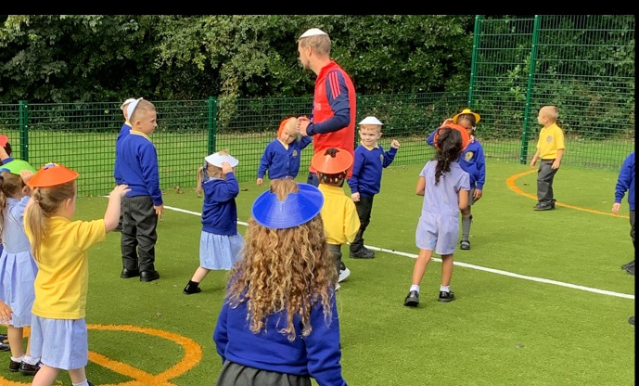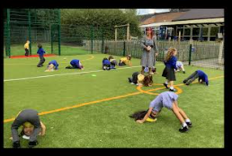

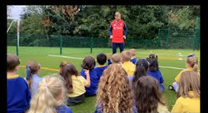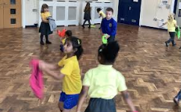

**Our P.E. Curriculum**

Children in Key Stages One and Two have two hours of taught physical activity per week. One hour is taught by their class teacher (following the “Get Set for P.E.” scheme) and the other is led by a member of the Manchester United community team (Primary Reds Programme) alongside their teacher.

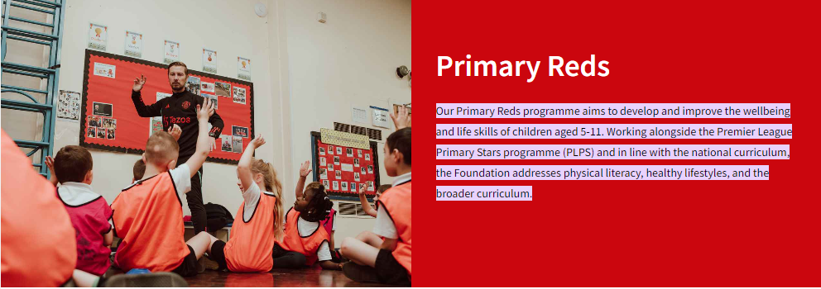

**St Bernadette’s P.E. Curriculum Map**

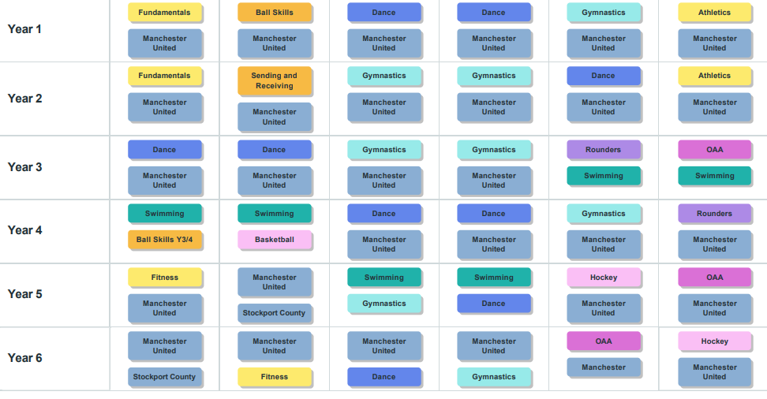

**Year 1**

|  |  |  |
| --- | --- | --- |
| Autumn 1  Fundamentals   * to explore balance, stability and landing safely * to explore how the body moves differently when running at different speeds * to explore changing direction and dodging * to explore jumping, hopping and skipping actions * To explore co-ordination and combination jumps * to explore combination jumping and skipping with a rope | Spring 1  Dance   * to use counts of 8 to move in time and make my dance look interesting * to explore pathways in my dance * to create my own dance using actions, pathways and counts * to explore speeds and actions * to copy, remember and repeat actions that represent the theme * to copy, repeat and perform actions that represent the theme | Summer 1  Gymnastics   * To explore travelling movements * to develop quality when performing and linking shapes * to develop stability and control when performing balances * to develop shape and control when performing shape jumps * to develop technique in the barrel, straight and forward roll * to link gymnastic actions to create a sequence |
| Autumn 2  Ball skills   * to develop dribbling a ball with your hands * to explore accuracy when rolling a ball * to explore throwing with accuracy towards a target * to explore catching with two hands * to explore dribbling a ball with your feet * to explore tracking a ball that is coming towards me | Spring 2  Dance   * to explore speeds and actions * to use expression and create actions that link to a story * to use a pathway when travelling * to explore and respond to actions relating to a theme * to create my own actions relating to an animal * to explore pathways with a partner | Summer 2  Athletics   * to move at different speeds over varying distances * to develop balance * to develop changing direction quickly * to explore jumping, hopping and leaping for distance * to develop throwing for distance * to develop throwing for accuracy |

**Year 2**

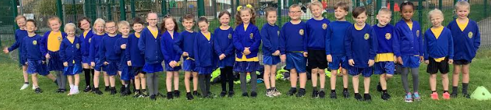

|  |  |  |
| --- | --- | --- |
| Autumn 1  Fundamentals   * to explore how the body moves running at different speeds * to develop changing direction and dodging * to develop balance, stability and landing safely * to explore and develop jumping, hopping and skipping actions * to develop co-ordination and combining jumps * to develop combination jumping and skipping in an individual rope | Spring 1  Gymnastics   * to perform gymnastic shapes and link them together * to perform gymnastics shapes with control and link them together * to use shapes to create balances * to use shapes to create balances * to connect balances and travelling actions using apparatus * to develop balances and travelling actions using apparatus | Summer 1  Dance   * to remember, repeat and link actions to tell the story of my dance * to develop an understanding of dynamics and how they can show an idea * use counts of 8 to help me stay in time with the music * to use facial expressions to show different characters * to explore pathways and levels * to remember and rehearse our circus dance showing expression and character |
| Autumn 2  Sending and receiving   * to roll a ball towards a target * to track and receive a rolling ball * to send and receive a ball with your feet * to develop catching skills * to develop throwing and catching skills * to send and receive a ball using a racket | Spring 2  Gymnastics   * to demonstrate different shapes, take off and landings when jumping * to develop different shapes, take off and landings when jumping * to develop rolling and sequence building * to refine rolling and sequence building * to create a sequence using apparatus * to perform a sequence using apparatus | Summer 2  Athletics   * to develop the sprinting action * to develop jumping for distance * to develop jumping for height * to develop throwing for distance * to develop throwing for accuracy * to select and apply knowledge in an athletics carousel |

Year 2 also has the weekly Manchester United Primary Reds Programme which covers invasion games/ sport (e.g. basketball, netball, football and rugby).

**Year 3**

|  |  |  |
| --- | --- | --- |
| Autumn 1  Dance   * to create actions in response to a stimulus and move in unison with a partner * to create to interact or make contact with a partner * to select and link appropriate dance actions and dynamics to show our idea * to remember, create and repeat actions to represent an idea * to create a dance that shows a location * to use choreographic devices to develop our dance | Spring 1  Gymnastics   * to be able to create interesting point and patch balances * to develop point and patch balances on apparatus * to develop stepping into shape jumps with control * to develop stepping into shape jumps on the apparatus * to develop the straight, barrel and forward roll * to include rolls in sequence work using apparatus | Summer 1  Rounders   * to learn how to score points in a striking and fielding game * to develop batting to score points * to develop fielding skills to limit the batter’s score * to understand the role of a bowler in the fielding team * to develop an understanding of tactics and use them in the game * to apply skills and knowledge to play games using rounders rules |
| Autumn 2  Dance   * to use straight pathways and changes in direction when performing a line dance * to use canon and unison to make our dance look interesting * to use formations, canon and unison to make our dance look interesting * to remember, repeat and create actions around a theme * to use formations effectively * to structure a dance to represent a theme | Spring 2  Gymnastics   * to be able to transition smoothly into and out of balances * to be able to transition smoothly in and out or balances using apparatus * to create a sequence with matching and contrasting actions and shapes * to create a sequence on apparatus matching and contrasting * to create a partner sequence using the skills I have learnt and a with a hoop * to create a partner sequence using the skills I have learnt using apparatus | Summer 2  OAA   * to develop cooperation and teamwork skills * to develop trust and teamwork skills * to involve all team members to work towards a shared goal * to develop trust whilst listening to others and following instructions * to be able to identify objects, draw and follow a simple map * to draw a route using directions, orientate a map and navigate around a grid |

Year 3 also has the weekly Manchester United Primary Reds Programme which covers invasion games/ sport (e.g. basketball, netball, football and rugby). In the summer term they will have swimming lessons at Life Leisure- Grand Central.

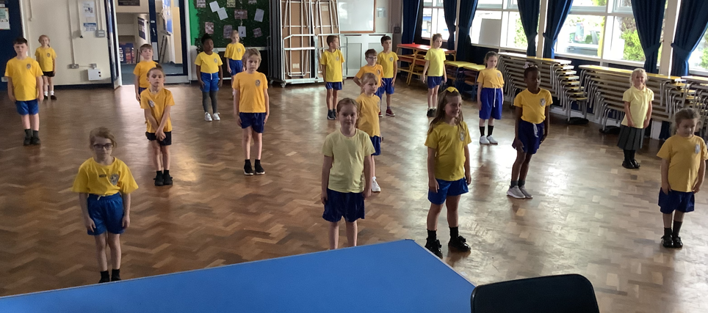

**Year 4**

|  |  |  |
| --- | --- | --- |
| Autumn 1  Ball skills   * to develop tracking and collecting skills * to develop confidence and accuracy whilst tracking a ball * to develop dribbling skills with hands and feet * to develop catching skills using one and two hands * to explore and develop a variety of throwing and catching techniques * to use tracking and sending skills with feet | Spring 1  Dance   * to copy and create actions in response to an idea and adapt this using changes in space * to choose actions that relate to the theme * to develop a dance using matching and mirroring * to learn and create dance moves to theme of carnival * to develop a carnival dance using formations, canon and unison * to develop a dance phrase and perform as part of a class performance | Summer 1  Gymnastics   * to develop individual and partner balances * to develop control when performing and landing rotation jumps * to develop the straight, forward, barrel and straddle roll * to link actions that flow to the rolls that I have learnt * to develop strength in inverted movements * to create a partner sequence using the skills i have learnt on the apparatus |
| Autumn 2  Basketball   * to develop attacking skills to move towards a goal * to develop passing and moving within the rules of the game * to develop movement skills to lose a defender and get into space * to develop defending skills to develop an attacker and intercept the ball * to use the space effectively to create shooting opportunities * to apply skills and knowledge to play games using basketball rules | Spring 2  Dance   * to understand how dynamics, space and relationships can be used to show ‘the states of matter’ * to use action, space, dynamics and relationships to represent a state of matter * to order and structure phrases to create a dance performance * to copy and repeat a set phrase in 1960’s style showing energy and rhythm * to learn and perform a partner dance in 1960’s style * to develop my own 1960’s inspired dance using relationships | Summer 2  Rounders   * to develop throwing and catching with accuracy and apply these to a fielding game * to develop bowling and learn the rules and skill within the game * to develop batting technique and understand where to hit the ball * to develop fielding techniques and apply them to a game situation * to play different roles within a game and start to think tactically about each of these roles * to apply skills and knowledge to compete in a tournament |

Year 4 also has the weekly Manchester United Primary Red’s Programme which covers invasion games/ sport (e.g. basketball, netball, football and rugby). In the autumn term they will have swimming lessons at Life Leisure- Grand Central.

**Year 5**

|  |  |  |
| --- | --- | --- |
| Autumn 1  Fitness   * to understand how speed helps me in other activities and apply this * to understand how strength helps me in other activities and apply this * to understand how agility helps me in other activities and apply this * to understand how balance helps me in other activities and apply this * to understand how co-ordination helps me in other activities and apply this * to understand how stamina helps me in other activities and apply this | Spring 1  Gymnastics   * to perform symmetrical and asymmetrical balances * to develop the straight, forward, straddle and backwards roll * to explore different travelling actions using both canon and unison * to perform progressions of inverted movements * to explore matching and mirroring in sequence work * to create a partner sequence using apparatus | Summer 1  Hockey   * to use attacking skills to beat a defender * to send and receive under pressure * to communicate with my team and move the ball forwards towards the goal * to learn defensive techniques to gain possession * to use defending tactics to gain possession * to apply skills, rules and principles to play in a tournament |
| Autumn 2 | Spring 2  Dance   * to create a dance using a random structure and perform the actions showing quality and control * to understand how changing the dynamics can change the appearance of the performance * to understand and use space and relationships to change a dance performance * to copy and repeat movements in the style of Rock and Roll * to work with a partner to copy and repeat actions in time with the music * to work collaboratively in a group to choreograph a dance in the style of Rock and Roll | Summer 2  OAA   * to develop communication and negotiation skills * to develop strong communication and negotiation skills to solve challenges * to develop planning and problem solving skills * to share ideas and work as a team to solve problems * to develop navigation skills and map reading * to create and follow a key and route on a map |

Year 5 also has the weekly Manchester United Primary Red’s Programme which covers invasion games/ sport (e.g. basketball, netball, football and rugby). In the Spring term they will have swimming lessons at Life Leisure- Grand Central. Stockport County lead their P.E. sessions in the second half-term of Autumn. 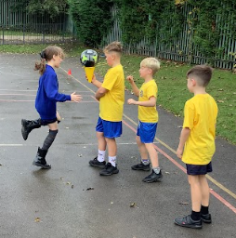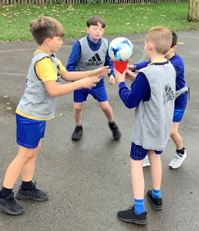

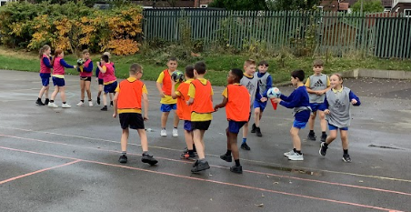

**Year 6**

**Year 6**

|  |  |  |
| --- | --- | --- |
| Autumn 1 | Spring 1  Dance   * to copy and repeat a dance phrase showing confidence in movement * to work with others to develop and explore the dance idea * to use changes in dynamics in response to the stimulus * to demonstrate a sense of rhythm in the dance style Bhangra * to perform a Bhangra dance showing an awareness of timing, formation and direction * to select, structure, order and perform in a Bhagnra style of dance | Summer 1  OAA   * to build communication and trust whilst showing and awareness of safety * to collaborate as a team to solve problems * to develop tactical planning and problem solving * to work as a team and use critical thinking to determine the best approach * to develop navigation skills and map reading * to use a key to identify objects and locations |
| Autumn 2  Fitness   * tp develop an awareness of what your body is able to do * to develop speed and stamina * to develop strength using my own body weight * to develop co-ordination * to develop agility * to develop balancing with control | Spring 2  Gymnastics   * to develop te straddle, forward and backward roll * to develop counter balance and counter tension * to develop jumps and explore the effect of height * to develop inverted movements with control * to use flight from hands to jump over apparatus * to create a group sequence using formations and apparatus | Summer 2  Hockey   * to develop dribbling to beat a defender * to send and receive the ball with control under pressure * to select the appropriate skill, when to pass and when to dribble * to move into and create space to support a teammate * to use the appropriate defensive technique for the situation * to apply rules, skills and principles to play in a tournament |

Year 6 also has the weekly Manchester United Primary Reds Programme which covers invasion games/ sport (e.g. basketball, netball, football and rugby). Stockport County lead their P.E. sessions in the first half-term of Autumn. 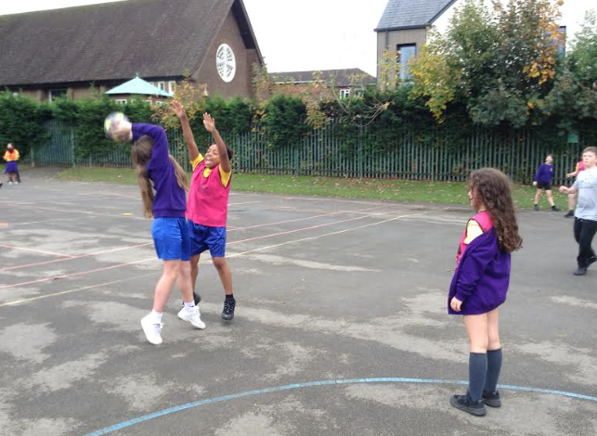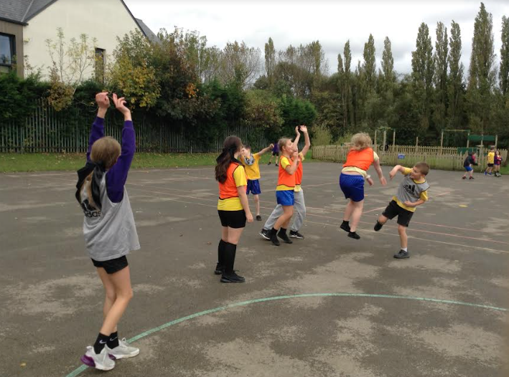

**Swimming**

**The Three National Outcomes:**

Swimming is the only sport to be included within the National Curriculum physical education programme of study. All primary schools **must** provide swimming and water safety lessons in either KS1 or KS2.

Each pupil is required to be able to do the following:

* Perform safe and self-rescue in different water based situations
* Swim competently, confidently and proficiently over a distance of at least 25 metres
* Use a range of strokes effectively, for example, front crawl, backstroke and breaststroke.

**Curriculum swimming lessons will start in Year 3 for St Bernadette’s children and will take place at Grand Central, Stockport.**

|  |  |  |  |
| --- | --- | --- | --- |
|  | **Autumn Term** | **Spring term** | **Summer term** |
| **Year 3** |  |  | **✅** |
| **Year 4** | **✅** |  |  |
| **Year 5** |  | **✅** |  |

**Equipment needed for All:**

Towel

Swimming cap (if hair is long)

All jewellery must be removed before school on your child’s swimming day

**Boys**

Swimming trunks (not shorts)

**Girls**

Swimming costume or a two-piece fitted top and shorts (no bikinis)

**Inclusion and SEND**

All children should have the opportunity to fully participate in P.E. at St.Bernadette's and we aim to remove any barriers that may prevent this.

**SEND**

We are fully inclusive and ensure that whole class teaching is accessible to all learners, making adaptations when needed for this to happen. In order for the P.E. curriculum to be accessible and inclusive for all, we need to anticipate potential barriers for individual learners and consider ways of minimising these to ensure participation. Some examples of our inclusive teaching strategies are listed below.

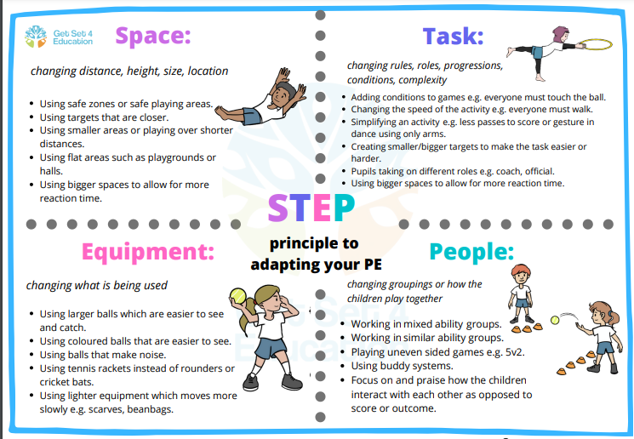

**P.E.kit**

To fully participate in P.E., students need the appropriate kit. We are lucky enough to have had brand new P.E. kits donated to the school by Stockport County Football Club, as part of their community fundraising efforts. Any child who doesn’t have a kit can access one from the office, which is freshly washed weekly for use by any child who may need one. 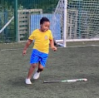

**P.E. kit (same for girls and boys)**

Yellow t-shirt

Royal blue shorts

Trainers

**Extra Curricular Activities**

We currently have 3 after school clubs- they do rotate half-termly so Key Stages 1 and 2 get a chance at all the activities.

|  |  |  |
| --- | --- | --- |
| Day : | Led by: | What and for who? |
| Tuesday | Stockport County | Year 5 and Year 6 girls’ only  Multi sports |
| Wednesday | Manchester United | Years 5 and 6 boys and girls  Multi sports |
| Thursday | Stars Dance | Years 2-6 boys and girls  Dance |

|  |
| --- |
| **Community Partnerships**  We are fortunate and proud to have partnered with Manchester United Primary Reds, Stockport County and Stockport Shapes Alliance. These groups, coupled with our class teachers are striving to create better outcomes for our children.  Manchester United Primary Reds gives us access to a specialist sports coach, after school club and excellent opportunities for our children to attend events at The Manchester United Foundation.  Stockport County Community Programme gives our Year 5/Year 6 children the opportunity to be taught by specialist coaches, and to access the after school club.  Stockport Shapes Alliance enables our children to attend sports competitions and festivals at schools within Stockport. Through partnering with the programme, we have built up good links with our nearby schools. Curriculum support is also offered from Shapes to our class teachers. |
|  |
|  |

**How do we assess P.E.?**

Children are assessed in P.E. through teacher judgement. At the end of each unit, children are assessed according to specific subject criteria. An example of which is below (Year 3 Dance unit 1). At the end of the year, the judgements are averaged and an overall outcome given.

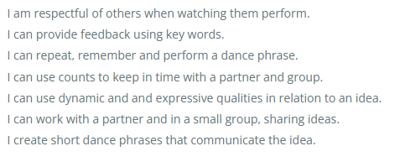

* Working towards the expected standard means that children won’t always demonstrate the criteria consistently.
* Working within the expected standard indicates that children demonstrate attainment of all of the criteria.
* Working beyond the expected standard indicates that children demonstrate all of the expected criteria and beyond.

**How is the subject monitored?**

The planning and coordination of the teaching in P.E. is the responsibility of the subject leader, who also:

* Supports colleagues in their teaching, by keeping them informed about current developments in the subject and by providing them with opportunities for continued professional development.
* Evaluate the strengths and weaknesses in the subject, and indicate areas for further improvement.
* Monitor children’s work, carry out Pupil Voice and observe P.E. lessons across the school in line with the Monitoring and Evaluation timetable.



**Recent fixtures and opportunities!**

**Year 3 and 4 Girls’ Football Festival**

